**Word Cloud Assignment**

**1. Introduction**

In this assignment, I analyzed the lyrics of the song "Heat Waves" by Glass Animals to generate word clouds. The objective was to compare two online tools, WordItOut and WordClouds.com, in terms of their capabilities and ease of use for creating word clouds from a text-based dataset.

**2. Step 1: Data Source**

* **Text-Based Data:** The data used for this analysis is the lyrics of "Heat Waves" by Glass Animals, a well-known song features a smooth, hypnotic beat and explores themes of longing, nostalgia, and unreciprocated love.
* **Reason for Choice:** I selected this song because whether you're in the mood for introspection or just want a laid-back, feel-good vibe, "Heat Waves" is a track that effortlessly combines both. Its infectious energy and emotional undertones make it a memorable listen.The diversity and frequency of words in the song make it ideal for generating meaningful and informative word clouds.

**3. Step 2: Word Cloud Creation**

**Tool 1: WordItOut**

* **Description:** WordItOut is a user-friendly tool that allows users to create word clouds quickly with basic customization options.
* **Customization:** For this word cloud, I selected a brown background color and used the default text orientation. I set the maximum number of words to 50 to highlight the most frequent terms in the lyrics.
* **Visualization:** The word cloud generated by WordItOut showcased prominent words such as "heat," "sometimes," and "waves”, which reflect the core themes and repetitive elements of the song.
* **WordItOut Word Cloud:**

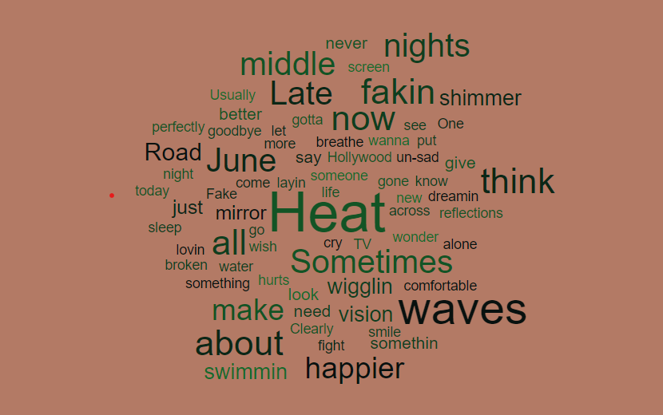

**Tool 2: WordClouds.com**

* **Description:** WordClouds.com provides a wide range of customization options, allowing for more creative control over the final word cloud.
* **Customization:** I chose a bulb shape for the word cloud and applied a blue color scheme. The word count was set to 11, with adjustments to highlight the most frequent words from the lyrics.
* **Visualization:** The resulting word cloud from WordClouds.com prominently featured words like "heat," "sometimes," and "waves”, arranged in a blue color effect, emphasizing the dynamic nature of the lyrics.
* **WordClouds.com Word Cloud:**



**4. Step 3: Comparison of Tools in Terms of Capability**

| **Feature** | **WordItOut** | **WordClouds.com** |
| --- | --- | --- |
| **Breadth of Functionality** | Basic functionality with limited customization options. | Extensive functionality with various customization options like shape, colors, and fonts. |
| **Flexibility** | Less flexible, primarily suited for straightforward visualizations. | Highly flexible, supporting complex designs and detailed customization. |
| **Graphics Production** | Produces simple, clear word clouds with basic design elements. | Capable of creating sophisticated word clouds with intricate designs and color schemes. |

**Opinion:** WordClouds.com excels in creating detailed and visually appealing word clouds, making it ideal for presentations or detailed analysis. WordItOut is effective for quickly generating basic word clouds with minimal effort.

**5. Step 4: Comparison of Tools in Terms of Ease of Use**

| **Ease of Use** | **WordItOut** | **WordClouds.com** |
| --- | --- | --- |
| **Learning Curve** | Very low; easy to use with minimal setup required. | Moderate; offers more options that require some exploration to use effectively. |
| **Intuitiveness** | Highly intuitive, with a simple and user-friendly interface. | Somewhat intuitive, though the many customization options can be overwhelming at first. |
| **Required Skills** | No special skills required; perfect for beginners. | Basic understanding of design principles enhances the use of advanced features. |

**Opinion:** WordItOut is perfect for users needing a quick and easy solution without delving into complex customization. WordClouds.com offers more advanced features but may require some time to get accustomed to, making it ideal for users seeking creative control.

**6. Conclusion**

In summary, WordClouds.com is the superior tool for users who want to create detailed and visually striking word clouds, especially for professional use. WordItOut, while simpler, is effective for quick and basic word cloud creation. Both tools offer valuable features depending on the user's needs and the complexity of the desired output.

Name: Mohammad Saud Khan

Roll No.: 2106039

KIIT University, Bhubaneswar